Unit 1- Prime Time- 2.3 Bagging Snacks: LCM and GCF Ms. Barbalaco (Turquoise)
Name_____________________________________________Group_______________________Date_________________

For Word Problems:
LCM Key Words GCF Key Words

C. Find the LCM and GCF of the following numbers:

49 and 14:

23 and 29:

16 and 48:

Unit 1- Prime Time- 2.3 Bagging Snacks: LCM and GCF Ms. Barbalaco (Turquoise)
Name_____________________________________________Group_______________________Date_________________

For Word Problems:
LCM Key Words GCF Key Words

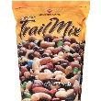

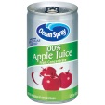

C. Find the LCM and GCF of the following numbers:

7 and 14:

13 and 5:

6 and 36:

