Unit 2- Comparing Bits and Pieces- Take Home Quiz #3 Mrs. Billinghurst (Turquoise)

Name_____________________________________________Group_______________________Date_________________

**I.** *Write the following numbers as a mixed number or improper fraction.*

1.  2. 

**II.** *Compare the following pairs of fractions using inequality symbols (<, >, =) & convert them to decimals.*

3.   4.  

**III.** *Convert all the following numbers to decimals and list them from least to greatest.*

5. 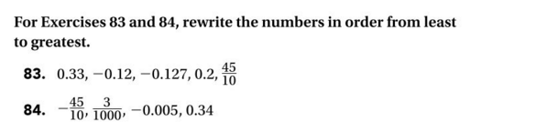

6. 