Unit 2- Comparing Bits and Pieces- Test Review #1 Mrs. Billinghurst (Turquoise)

Name_____________________________________________Group_______________________Date_________________

**Part I: Equivalent Fractions Strategies**

* Fraction strips
* Common denominator (LCM)
* Use of Benchmarks

*Write an inequality statement:*

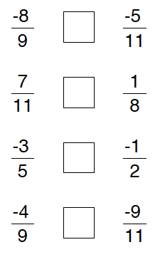 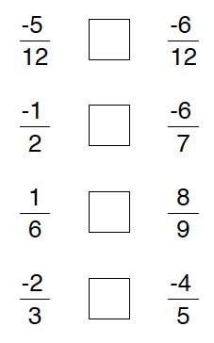 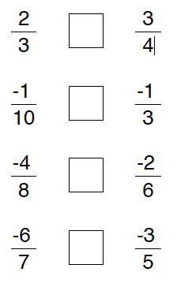

**Part II: Ratios/ Proportions**

Three ways to write: 1.______________________ 2. ______________________3. ______________________

Katie said, “The ratio of people to pets in my family is 2 to 1.” If her family has three pets, how many people are in the family?

For every statement: ___________________________________________________________________

**Part III: Rational Numbers include:**

1.________________________________ 2. ________________________________3. ________________________________

*Label the arrows below as both a fraction and a decimal:*

↓

C.

↓

B.

↓

A.

Screen Shot 2014-11-17 at 9.05.54 PM.png

-4

4

3

2

-3

1

-2

-1

0

1. Fraction:______________ B. Fraction:______________ C. Fraction:______________

Decimal: ______________ Decimal: ______________ Decimal: ______________

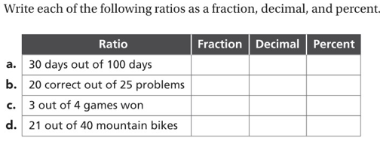

Screen Shot 2014-11-17 at 8.48.42 PM.png1.

**Part IV: Unit Rate/Rate Table**

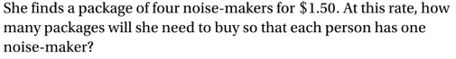

2.

Screen Shot 2014-11-17 at 8.48.57 PM.png

3.

Screen Shot 2014-11-17 at 8.49.09 PM.png

4.

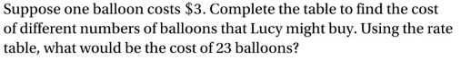

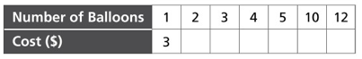

**Part V: Improper Fractions/Mixed Numbers**

*Write the mixed numbers as improper fractions. Write the improper fractions as mixed numbers.*

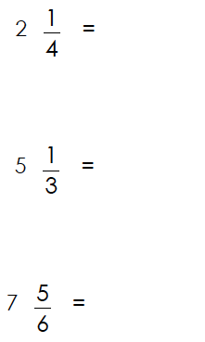 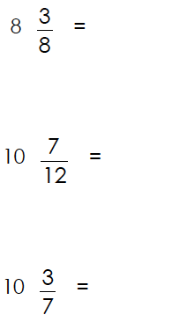 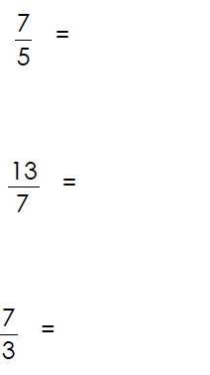 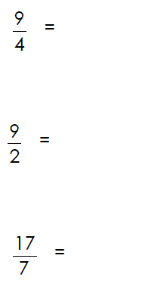

**Part VI: Percents**

*Rewrite the fractions into decimals and percents:*

   

Strategies: Division (numerator by denominator) Benchmarks Ten Based Numeration