**Part I: Decimals on the number line**

Unit 2- Comparing Bits and Pieces- Test Review #2 Mrs. Billinghurst (Turquoise)

Name_____________________________________________Group_______________________Date_________________

1. For each number line, fill in the missing decimal numbers.

**SAMPLE: ANSWER:**

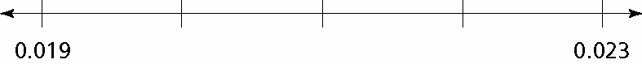 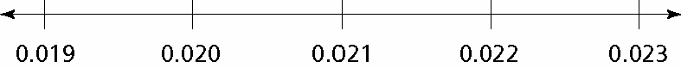

**a.** 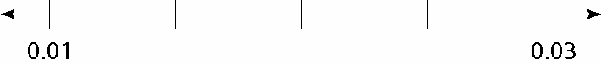

**b.** 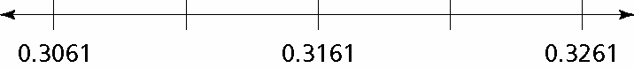

**c.** 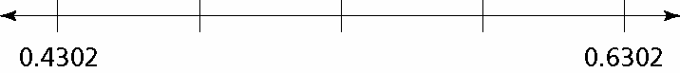

2. Put the following set of numbers in order from least to greatest in decimal form:



Remember:



**Part II: Conversions**

3. Fill in the missing parts of the table.

|  |  |  |
| --- | --- | --- |
| Fraction | Decimal | Percent |
|  |  |  |
|  | 0.88 |  |
|  |  | 35% |
|  |  |  |
|  | 0.625 |  |
|  |  | 275% |

4. Rewrite the percent of 15% as a fraction (simplify if possible) and as a decimal:

**Part II: Word Problems**

5. Out of a class of 40 students, there are 8 students that have dimples.

a. What is the fraction of students that do not have dimples?

b. What is the percent of students that do not have dimples?

6. In a class of 24 sixth-graders, 25% walk to school,  ride bicycles to school,  take the bus, and the remainder of the class are driven to school by their parents or guardians.

**a.** How many students in the class walk to school?

**b.** How many students in the class ride bicycles to school?

**c.** How many students in the class take the bus to school?

**d.** What fraction of the class are driven to school by their parent or guardian?

**e.** What percentage of the students in the class walk, ride bicycles or the bus, or are driven to school by a parent or guardian?