WELCOME BACK!!
I have been waiting all summer to finally meet you and am very anxious to get to know you as soon as possible. I will be giving you plenty of information about myself and the wonderful events that will be happening throughout the year. This is your opportunity to let me know all about you. Please answer the following questions openly and honestly. I look forward to getting to know you and spending this year with you.

THE BASICS:
Name: _________________________________________________________________

Name you would like to go by: _______________________________________________

Date of Birth: ____________________________________________________________

PEOPLE YOU LIVE WITH:

His/Her Name Relationship
_____________________________________________ _______________________
_____________________________________________ _______________________
_____________________________________________ _______________________
_____________________________________________ _______________________
_____________________________________________ _______________________

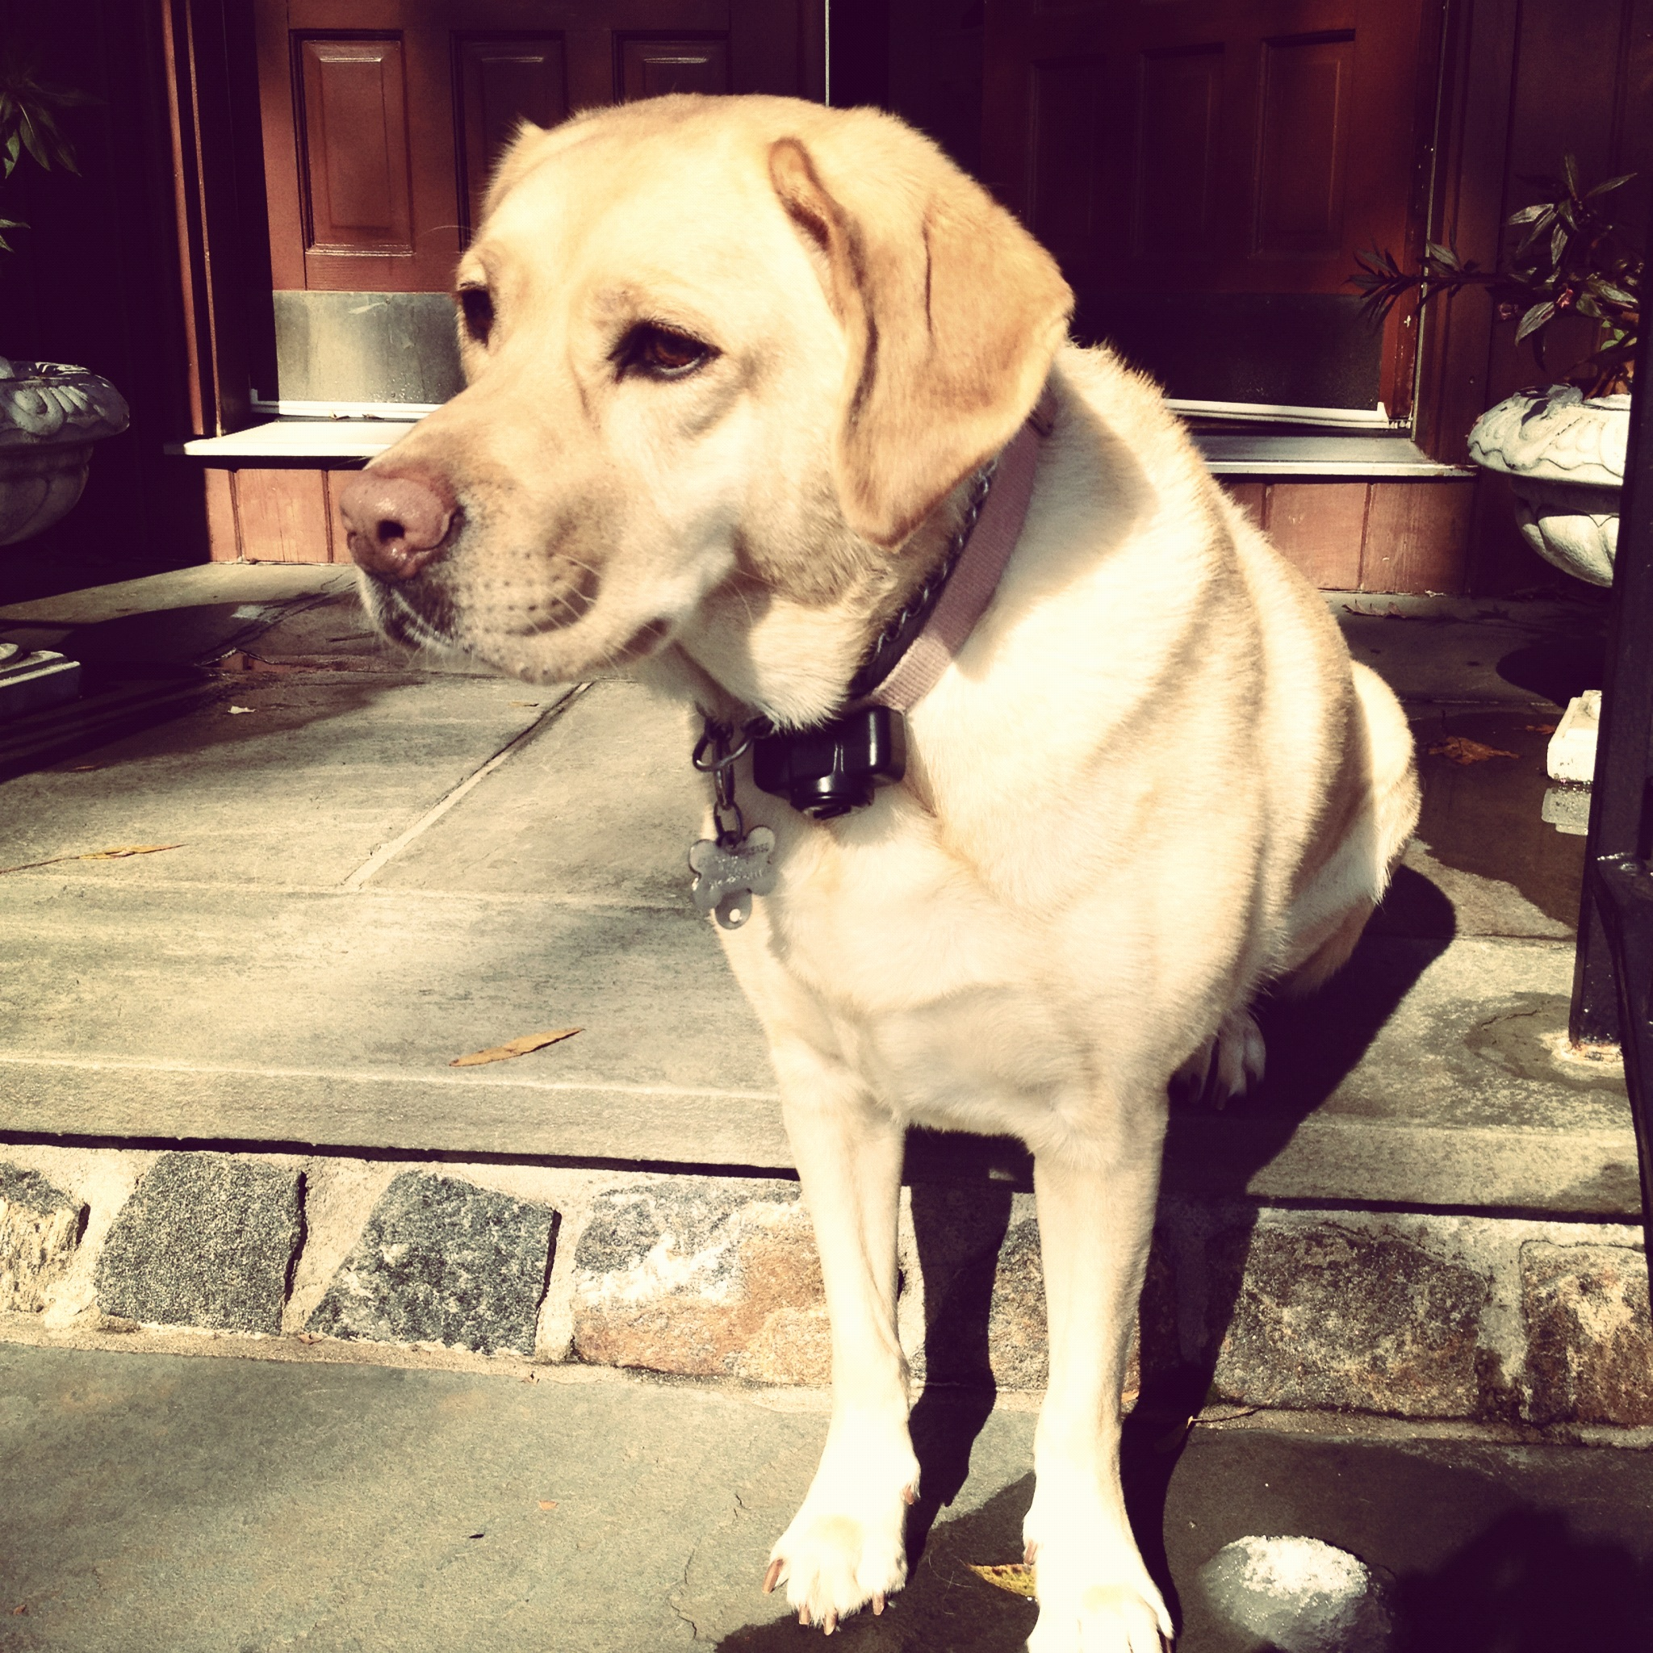
FUN FACT about
Ms. Barbalaco:
The picture on
the left is a
picture of Summer, Ms. Barbalaco’s yellow Labrador retriever.

PET(S): (check the box and fill out the information, if applicable)

☐I have no pets. ☐I have ____(1, 2…) dog (s). ☐I have ____(1, 2…) cat (s).
Name:________________________ Name: __________________
Name:________________________ Name: __________________
Name:________________________ Name: __________________
Name:________________________ Name: __________________

WHAT DO YOU LIKE TO DO?

After School: _____________________________________________________________

On Weekends: ___________________________________________________________

A day off from school: _____________________________________________________

Hobby/Hobbies: __________________________________________________________

How long have you been doing it? _______________________________

FAVORITES:

Movie:___________________________

TV Show:_________________________

Book:____________________________

Magazine:________________________

Sports Team:______________________

Sport:____________________________

Friend:___________________________

Food:____________________________

Gym Game:_______________________

Type of Music:_____________________

Song:____________________________

Artist:____________________________

SCHOOL THINGS:

*Favorite Subject:_________________________________________________________

*Why do you like that subject?_______________________________________________

________________________________________________________________________

*Least Favorite Subject:____________________________________________________

*Why don’t you like it as much as other subjects?_______________________________

________________________________________________________________________

*How do you like to learn (Circle One)?

By Listening By Looking By Using My Hands

*How do you learn best (Circle One)?

Working in a group Working with one other person Working by myself

*Where do you prefer to sit in a classroom (Circle One)?

In the front In the middle In the back

*How would you rate yourself in math (Circle One)?

1 2 3 4 5
It is my hardest I struggle with Average I do well on I get all problems
subject. most problems. most problems. correct.

HOPES/WISHES:

This year I look forward to:__________________________________________________

________________________________________________________________________

________________________________________________________________________

